Structure Directory Mac OS

/Applications
Berisi aplikasi apa saja yang ada di mac OS

/Developer
The Developer directory appears only if you have installed Apple’s Developer Tools, and no surprise, contains developer related tools, documentation, and files.

/Library
Berisi file yang diperlukan agar OS berjalan dengan back, termasuk pengaturan, preferensi, dan kebutuhan lainnya.
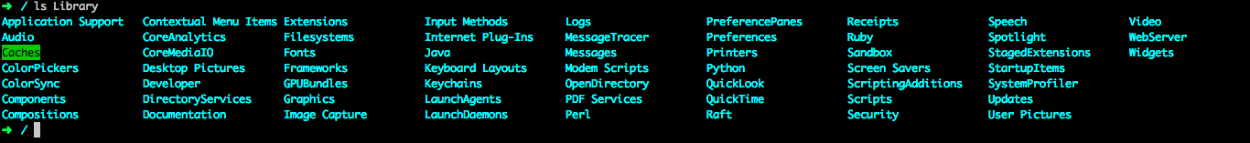

/System
Berisi file yang berbuhungan dengen sistem, libraries, preferensi untuk menjalankan fungsi-fungsi Mac OS
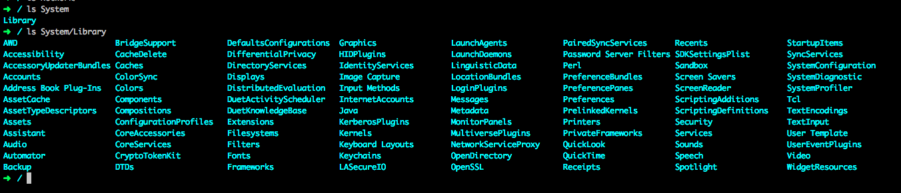

/Users
Berisi dastar user yang ada di Mac OS
/Volumes
Mounted devices and volumes, either virtual or real, such as hard disks, CD’s, DVD’s, DMG mounts, etc
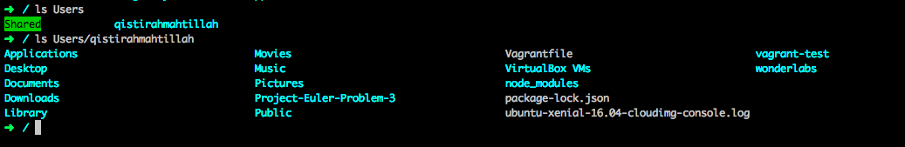
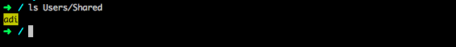

/bin
Essential common binaries, holds files and programs needed to boot the operating system and run properly
/etcMachine local system configuration, holds administrative, configuration, and other system files
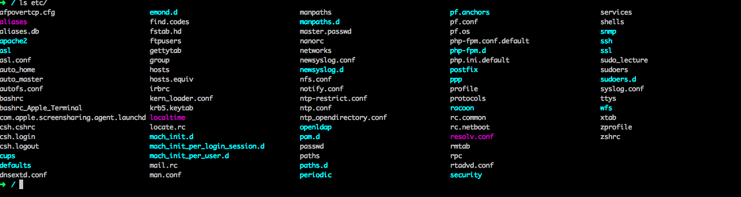
/dev
File perangkat, semua file yang mewakili perangkat periferal termasuk keyboard, mouse, trackpad, dll.
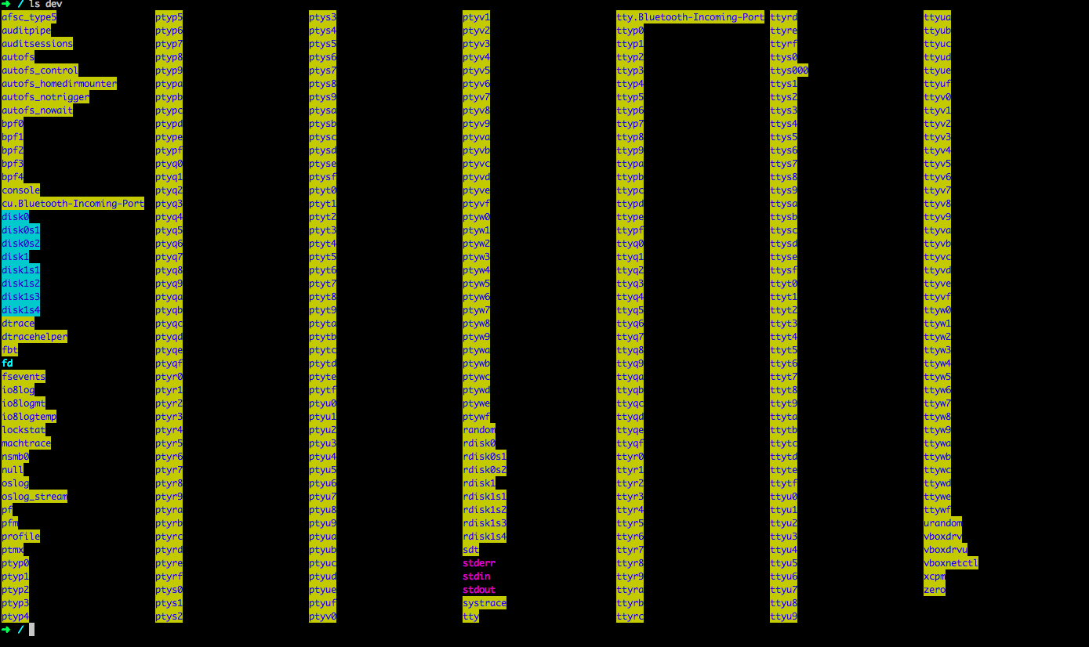

/usr
Hirarki utama kedua, mencakup subdirektori yang berisi informasi, file konfigurasi, dan keperluan lainnya yang digunakan oleh sistem operasi

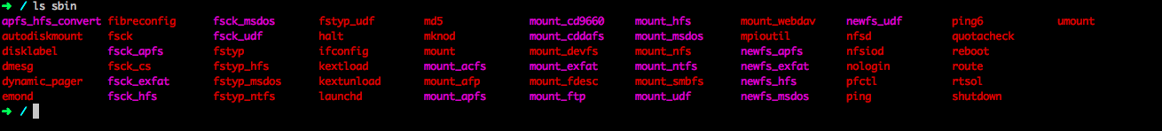
/sbin
Sistem binari penting, berisi utilitas untuk administrasi sistem
/tmp
File temporary attar file sementara
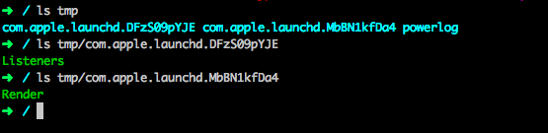

/var
Data variabel, berisi file yang isinya berubah saat sistem operasi berjalan
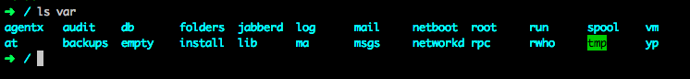

DIRECTORY UBUNTU XENIAL

/-Root
The starting point of your directory structure. This is where the Linux system begins.
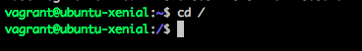

/bin
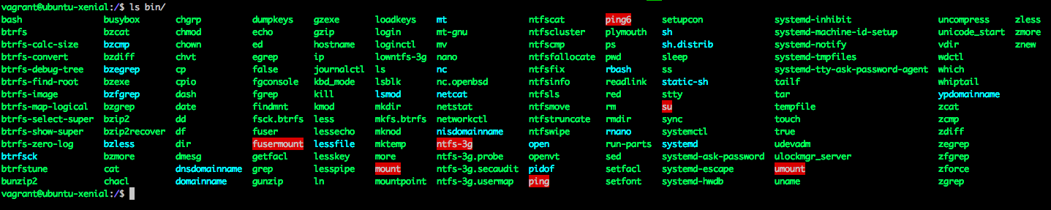
Contain the most important programs that the system needs to operate, such as the shells, ls, grep, and other essential things.
/sbin - System binaries
Most system administration programs are stored in these directories.
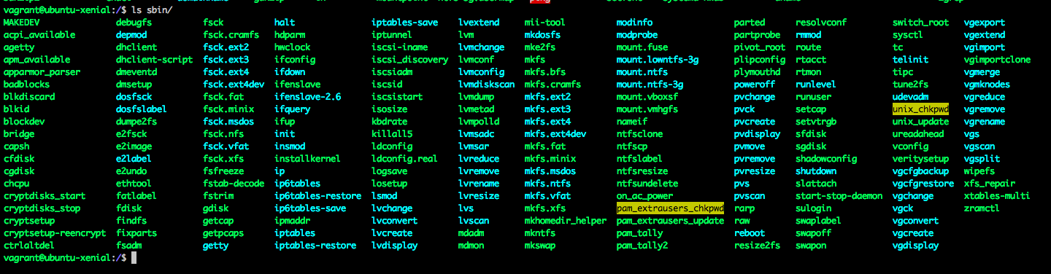
/etc
It contains files required by all programs
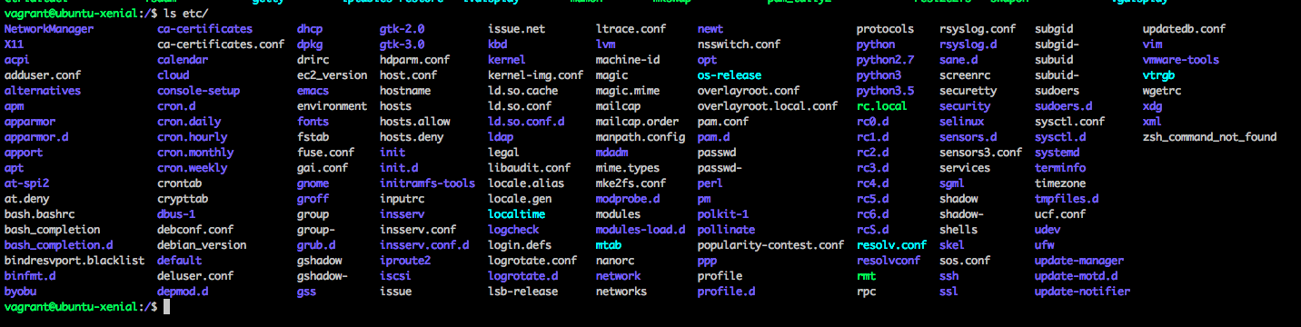
/dev - Device File
The divices that are available to a Linux system.
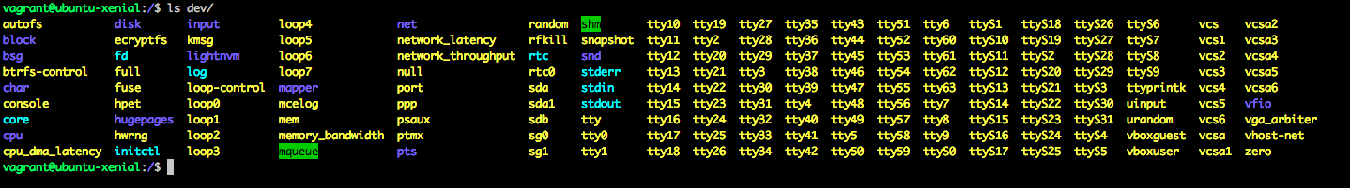
/proc - Process Information
This is a special directory. Well, actually /proc is just a virtual directory because is doesn’t exist at all, it contains some info about kernel itself
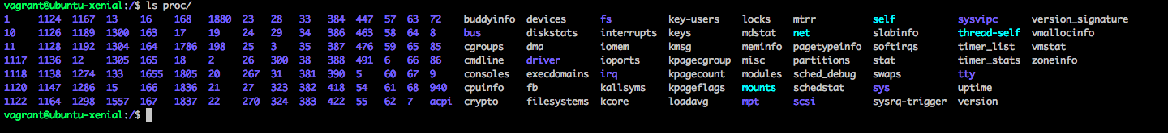
/var - Variable Files
This directory contains variable data that changes constantly when the system is running.

/tmp – Temporary Files
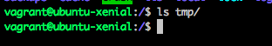
Programs can write their temporary files here.

/usr – User Programs
This directory contains user applications and a variety of other things for them, like their source codes, and pictures, docs, or config files they use. /usr is the largest directory on a Linux system, and some people like to have it on a separate partition.
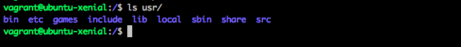

/home – Home Directories
This is where users keep their personal files. Every user has their own directory under /home, and usually it’s the only place where normal users are allowed to write files. You can configure a Linux system so that normal users can’t even list the contents of other users’ home directories.

/boot – Boot Loader Files
As the name suggests, this is the place where Linux keeps information that it needs when booting up.
/lib – System Libraries
The shared libraries for programs that are dynamically linked.
/mnt – Mount Directory
Temporary mount directory where sysadmins can mount filesystems.This directory is used for mount points. The different physical storage devices (like the hard disk drives, floppies, CD-ROM’s) must be attached to some directory in the file system tree before they can be accessed.

/srv – Service Data
srv stands for service.Contains server specific services related data

